|  |  |
| --- | --- |
| A picture of a winding road and trees  **Ethical use of Artificial Intelligence In The Programming and Technology Sector**  Practical Assessment Task (PAT) | Abstract  [Draw your reader in with an engaging abstract. It is typically a short summary of the document. When you’re ready to add your content, just click here and start typing.]  Molamo Tungwane  Computer Application Technology (CAT) |

Table of Contents

***INTRODUCTION: ....................................................... 8***

***TASK DEFINITION:..................................................... 8***

**Focus Question ........................................................................................................................ 8**

***CONTENT: .......................*** *Error! Bookmark not defined.*

**Questions & Source Table ........................................................................................................ 0**

***FINDINGS: ................................................................ 0***

***CONCLUSION: ........................................................... 0***

***BIBLIORAPHY: .......................................................... 0***

***APPENDICES ............................................................. 0***

**1)Folder Structure .................................................................................................................... 0** **2) Declaration Of Authenticity .................................................................................................. 1**

1. ***Sources ................................................................. 2***
2. **Quality ................................................................................................................................. 3**

INTRODUCTION:

The ethical use of artificial intelligence is the ability to use the Technology in a way that is in line with the moral and values of the world. Artificial intelligence is rapidly integrated into all these various sectors especially in the Programming and Technology sectors.

The World Economic Forum has released an Ethics by designed aimed to an Organisational approach to the responsible use of Technology in lining with the Ethical use of Technology in the curial success of the forth industrial Revelation. Ethical use of Ai will be a key role to the success of the forth Industrial revelation in it shaping the industry

TASK DEFINITION:

Lately people have become aware of Ai, thus my school asked me to make research on the ethical use of Ai in the programming and technology sector and the impact of the AI tool.

My investigation will be focussing on the ethics of using Ai in the Technological field. I will investigate on how Ai can be used ethically in this field and on how it has its challenges both Positive and negative.

My research will have to be conducted into 3 phases where in phase 1 will be my planning and research on the ethical use of Ai. In phase 2 I will be creating questionnaires and spreadsheet and database to Annalise on my findings from my phase 1. In my phase 3 I will be creating a website to present my finding on my entire PAT.

I’m doing this research to get people aware of how to use AI tools ethically, even though it can give them they entire search and presenting it unaware of the fact that presenting work from an AI is unethical, I’m hoping to spread the word out to avoid this in future and to get a world to use AI ethically.

Focus Question

**How can we get people to become aware on using Ai ethically?**

# Questions & Source Table

|  |  |  |  |  |  |  |  |  |
| --- | --- | --- | --- | --- | --- | --- | --- | --- |
| **No.** | **Category** | **Question** | **Q. Level**  **(1-4)** | **Type of Source** | **Bibliography** | **Quality of information** | **Summary of information** | |
| Heading 1: Problem | | | | | | | | | |
| 1. |  |  |  |  |  |  |  | |
| 2. |  |  |  |  |  |  |  | |
| 3. |  |  |  |  |  |  |  | |
| Heading 2: Impact | | | | | | | | | |
| 4. |  |  |  |  |  |  |  | |
| 5. |  |  |  |  |  |  |  | |
| 6. |  |  |  |  |  |  |  | |
| Heading 3: Solution | | | | | | | | | |
| 7. |  | How can we get people to become aware on using Ai ethically? |  |  |  |  | |  |
| 8. |  |  |  |  |  |  | |  |
| 9. |  |  |  |  |  |  | |  |
| 10. |  |  |  |  |  |  | |  |

FINDINGS:

(TO BE DONE IN PHASE 2/3)

CONCLUSION:

(TO BE DONE IN PHASE 2/3)

BIBLIORAPHY:

(TO BE DONE IN PHASE 2/3)

APPENDICES

# 1)Folder Structure

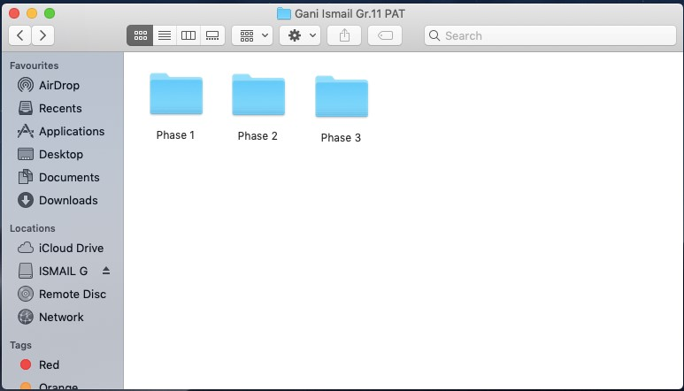

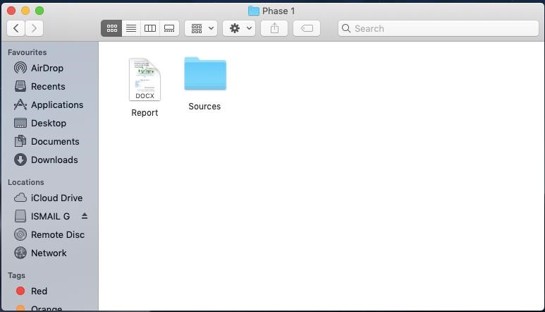

# 2) Declaration Of Authenticity

# 3) Sources

|  |  |
| --- | --- |
| Article Source 1 |  |
| Author(s) | [Michael Weinzettl](https://www.amazon.com/s/ref=dp_byline_sr_book_1?ie=UTF8&field-author=Michael+Weinzettl&text=Michael+Weinzettl&sort=relevancerank&search-alias=books) |
| Title of source | Online Collaboration: New Business Opportunities |
| Date published/issued | October 28, 2010 |
| Publisher | VDM Verlag Dr. Müller |

## 4) Quality

Internet SOURCE 1 QUALITY Criteria: Explanation:

Authority The author Casey Schmidt, is a reporter and journalist for Canto. She writes numerous articles for the company that are recognized world-wide for their factual information.

Currency The article was published last year on the 4th October 2019, the website however is updated daily.

Accuracy The website fully corresponds with the information displayed by the other sources as well as similar sources.

Objectivity There is no evidence of prejudice, bias, skewing of information etc. Everything is written in own or similar words from the author.

Coverage The website covers the topic fully and gives clear and factual information.

Internet SOURCE 2 QUALITY Criteria: Explanation:

Authority The article is written and moderated by 3 different authors, Nicholas Fearn, Steve MacCaskil and Brian Turner. Each of these authors have a history in writing about this topic and providing accurate and factual information to readers.

Currency The article was written quite recently, on the 27th March 2020, which shows that the information is relevant and current.

Accuracy The information available in this article is relevant and corresponds with information available on similar websites.

Objectivity There is no evidence of prejudice, bias, skewing of information etc. Everything is written in own or similar words from the author.

Coverage The website covers the topic fully and gives clear and factual information.

Internet SOURCE 3 QUALITY Criteria: Explanation:

Authority The article is published and written by EZ Talks, which is an online collaboration software company itself, thus it is fully qualified to give trustworthy and accurate information regarding this topic.

Currency The Article was written on the 5th September 2019 which is quite recently making the information relevant and accurate.

Accuracy The information displayed on the website fully corresponds with information in the other sources as well as similar sources.

Objectivity There is no evidence of prejudice, bias, skewing of information etc. Everything is written in own or similar words from the author.

Coverage The website covers the topic fully and gives clear and factual information.

Article SOURCE 1 QUALITY Criteria: Explanation:

Authority The author Michael Weinzittl is a well-recognized author who has written many articles and books regarding similar topics. His information in his work is regarded as factual and not bias.

Currency The book was written and published in 2010 which is relatively recent.

Accuracy The information available in the book is accurate and corresponds fully with the information on the other sources.

Objectivity There is no evidence of prejudice, bias, skewing of information etc. Everything is written in own or similar words from the author.

Coverage The website covers the topic fully and gives clear and factual information.